Analyzing and Predicting the Effect of Climate Change Factors on Buffalo’s Weather.

Data Intensive Computing

Team:

Balasubramanian Chandrasekar

Shankarram Saravanan

Prof. Erik Mikida

Dec 04, 2022

Phase 3 - Data Product and Project Wrap-Up

# Notes on code and recommendations

For detailed instructions on how to run the code and how to use the application, please refer to the readme included in the top level directory of this submission.

Below is attached the screenshot of the application.

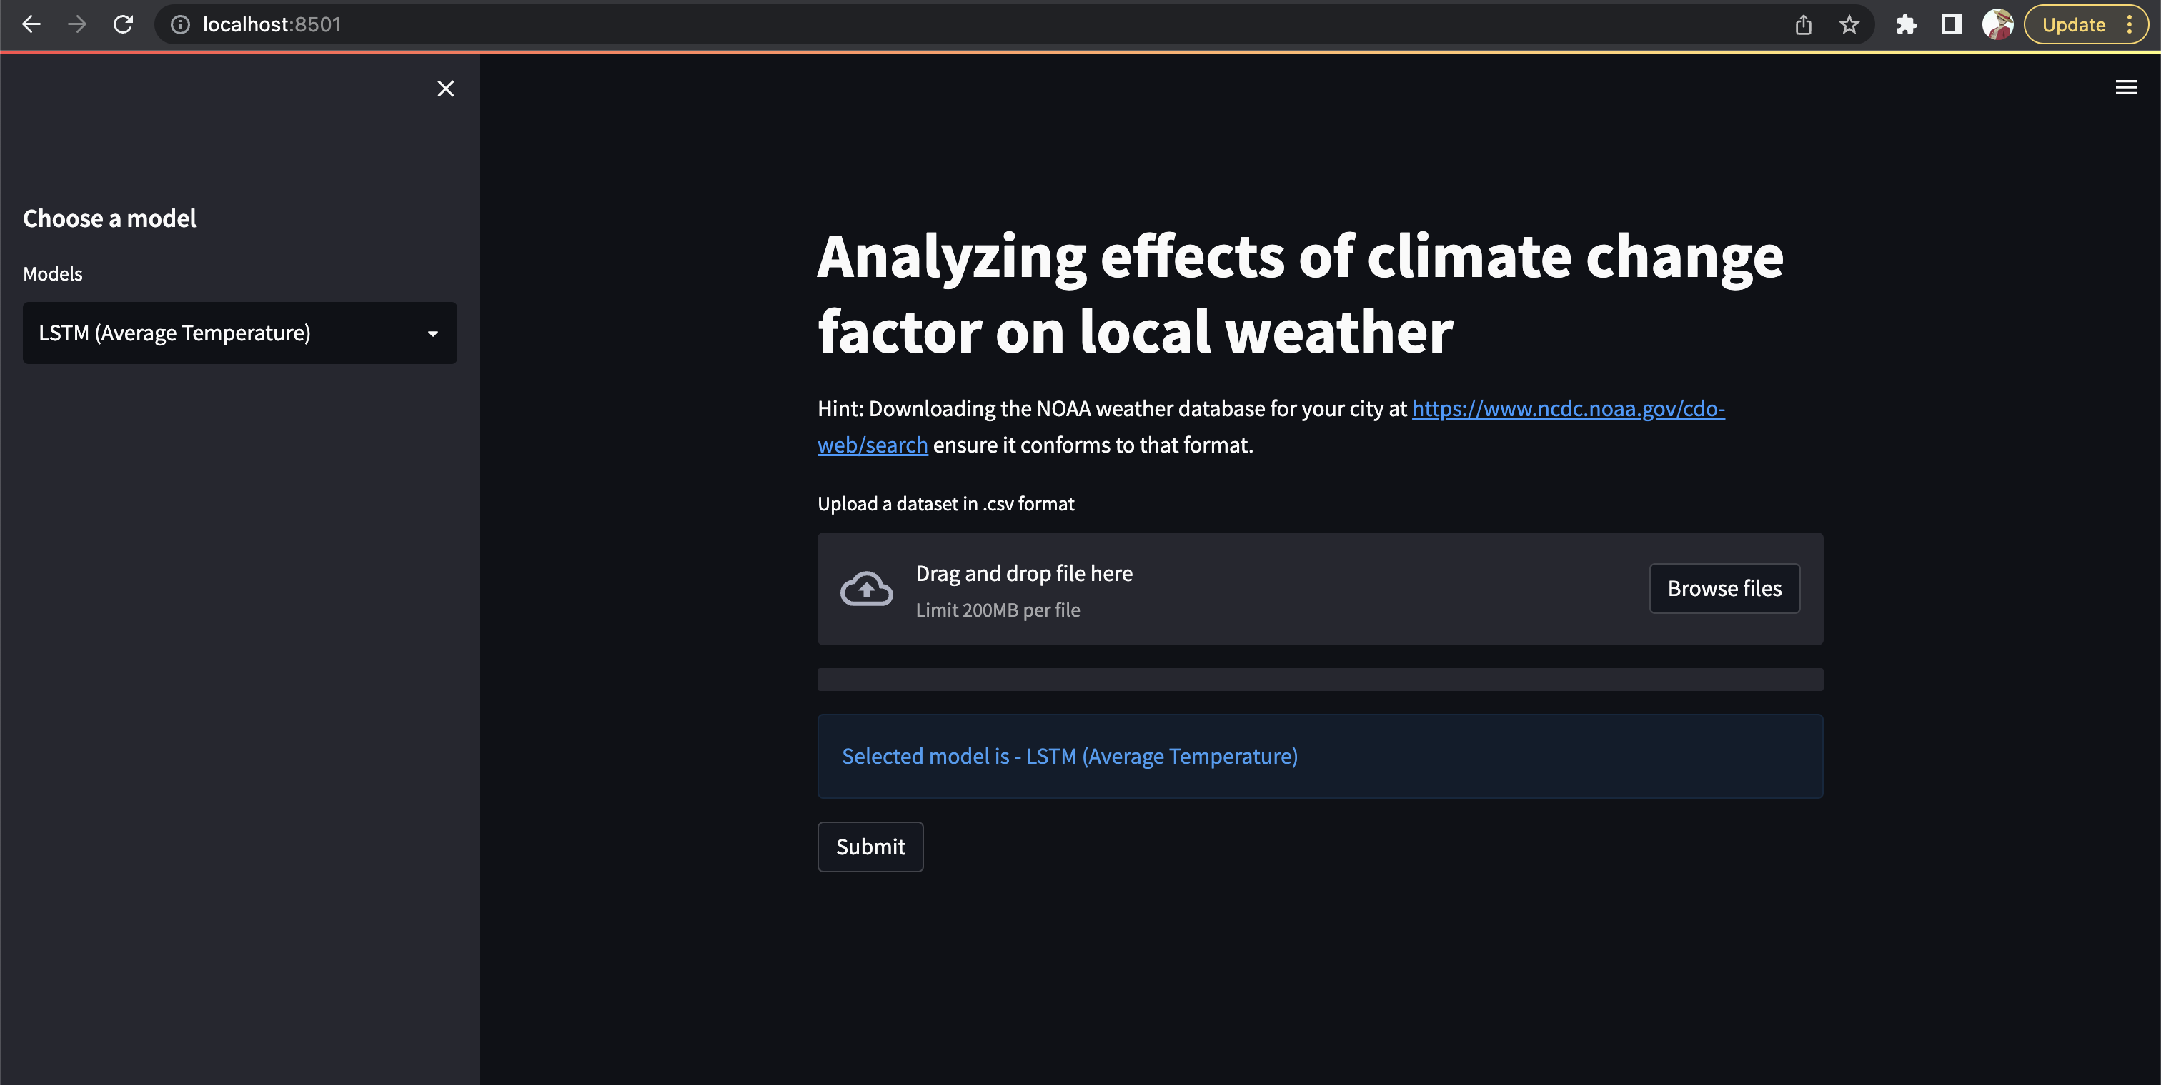

b. Models used from Phase 2

We used 2 models from phase 2

- LSTM

- Random Forest

Additional model

- Prophet

We used LSTM to predict the average temperature for the next 7 days. For LSTM, we used the Adam optimizer with a learning rate of 0.001 with a batch size of 120 and epoch of 100

The random forest model was used to predict the CO2 values for the next 365 days. For this model, we used 200 as the number of estimators and a max depth of 70.

We also implemented an additional model — Prophet. With this model, we give the users ability to get the number of days for which they want to get the prediction of average temperature for.

c. Recommendations

From the models we’ve implemented, users can get to know the average temperature prediction for the next 7 days through the LSTM model and next n days with the prophet model. They can also see how the weather has changed over a course of many years and how the increase in carbon dioxide levels have affected their local weather through various visualizations that the application provides after the analysis.

Users also have the ability to upload their own datasets in the csv format following the specifications provided in the readme file.

After working on the project, we can safely say that climate change is real and we have observed the average temperatures have risen in every city. To also

This project can be extended by enhancing the accuracy of the prediction through increasing the number of features we analyze. More features could be added to the dataset to increase the accuracy of the prediction.